Cadence AMS training – Instructions for attendees

- This is a hands-on training session in a conference space. Please bring your own laptops, power cords and any other accessories that will help you focus on the learning experience.
- Modules
  - Mod1: Flow overview
  - Mod2: Functional Verification
  - Mod3: Floor planning
  - Mod4A: Design capture and simulation
  - Mod4B: Constraint aware analog simulation
  - Mod5: Electrically aware design
  - Mod6: Physical Verification
  - Mod7: IP Packaging

- Tentative Schedule is as shown in the chart below. It will be adjusted as needed based on the class pace. For example, Module2 may be started on day 1 if time permits.
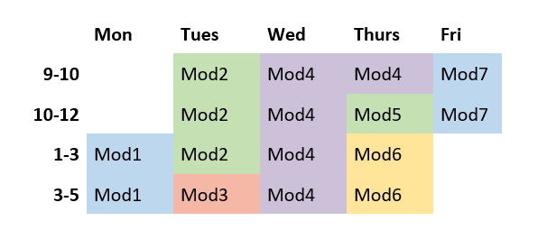
- Soft copies of all the training material will be available through CMC cloud
- Please follow the instructions below to create your cloud instance prior to the session on Monday, March 2nd.
- The following doc provides general information on how to use CMC cloud service:
https://community.cmc.ca/docs/DOC-2353#jive_content_id_Uploading_and_Downloading_Files
- Following is a list of steps with snapshots specific to this course. Please refer to the link above for Figure numbers.
- Go to https://vcad.cmc.ca
- Login with your CMC account
- You will see Fig-1

- Click “Create My Instance”
- Click on “Create Instance” for Cadence AMS Training Fig-2
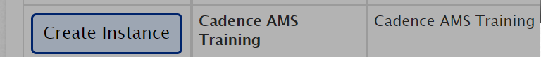
- Fig-3 shows up. Create instance
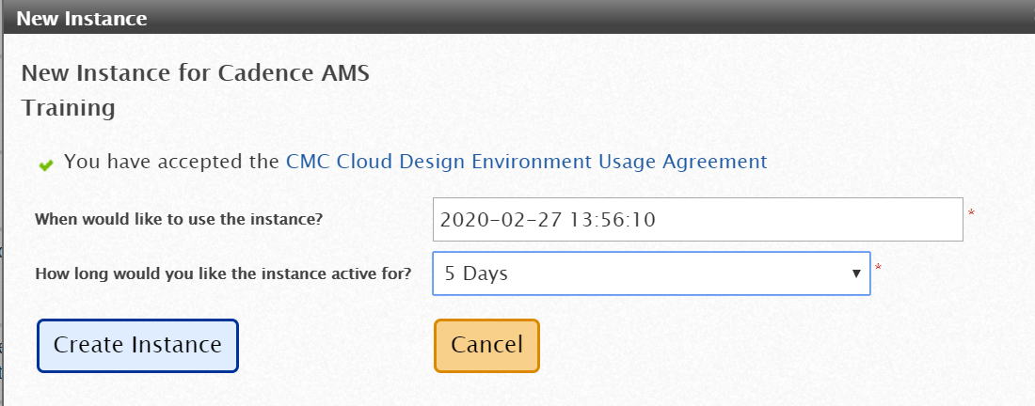
- Click “Connect” Fig-4
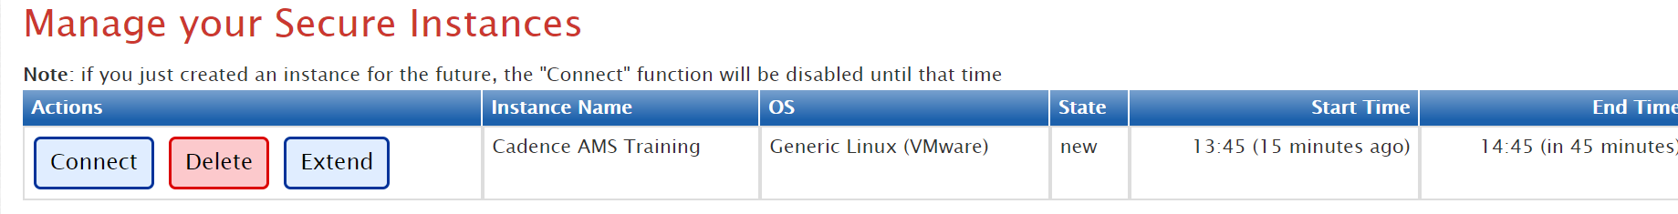
- If you see the message below, please wait for your browser to refresh / till the connection is established
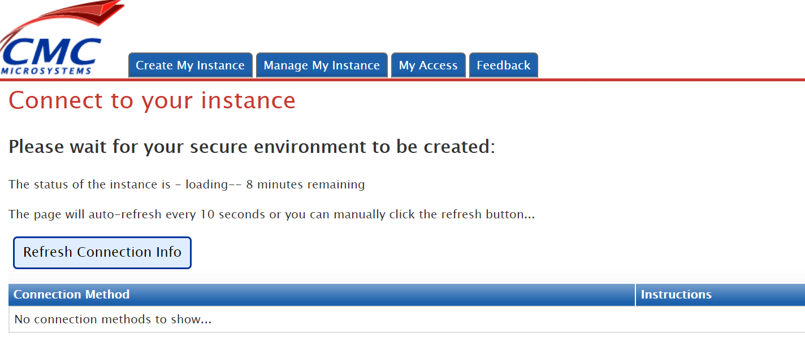
- You will need to install the NoMachine client and MobaXterm client, then click “open Desktop” or “Open Terminal” Fig-5
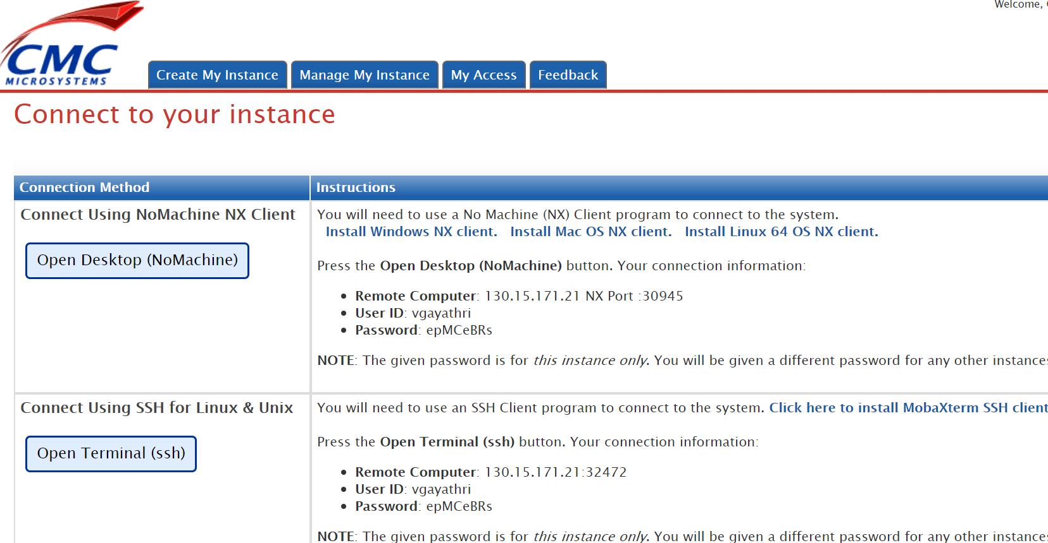
- Please note, the User ID and Password for cloud instance are different from CMC login, and are as indicated in the snapshot shown above.
- After logging into your cloud instance, please create a working directory under mydata directory.
    - The PDK is under /CMC/kits
    - The Cadence tools are under /CMC/tools/cadence
    - If you have any questions, please write to fab@cmc.ca

- Venue-specific logistics:
  - Training starts at noon on Monday with lunch and ends on Friday just before lunch.
  - Lunch will be served on Monday-Thursday, not on Friday
  - There will be one power bar available per table with 3 power outlets, for 5-6 people per table. Please plan to time-share your device charging schedules

